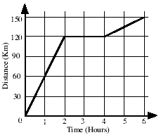 | 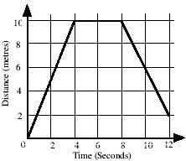 | 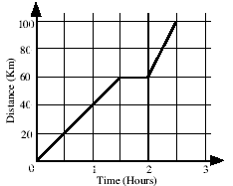
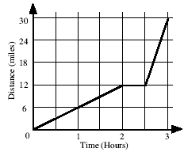 | 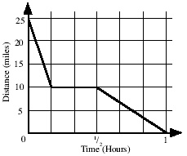 | 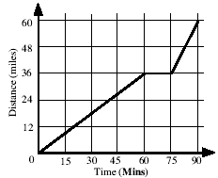
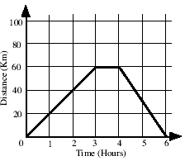 | 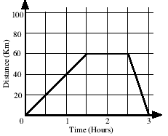 | 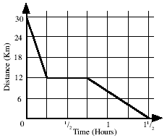

A car travels at 60 km/h for 2 hours on the motorway. It stops at the service station for two hours, then travels in heavy traffic at 15 km/h for 30 km | A toddler rides his bike up the pavement for 10m. He then turns around and rides back. 2m from home, he hits a bump and falls off his bike. | A coach leaves the station at 10am and reaches Gloucester station at 11.30am. It stops here for half an hour. It then carries on for 30 minutes reaching Worcester 40 km later.
A cyclist rides for 2 hours travelling at 6 miles per hour. He then stops to rest for 30 minutes then continues for a further 18 miles. | A train is travelling back to Bristol at a speed of 90 mph. A tree has fallen on the track at Bath and the train stops for 20 minutes while it is cleared. The train then travels the remaining 10 miles slowly. | A motorbike rider rides for 36 miles at a steady speed. She stops to read the map for 15 minutes then rides for the remaining 24 miles at a very illegal 112 mph.
A man drives to his friend’s house at a steady speed of 20 km/h, stops for an hour then returns home in 2 hours. | A bus leaves school at 9am and gets to its destination at 10.30am. The children look around the museum for an hour then return back to school. The bus arrives back at midday. | A cyclist rides downhill towards home for 15 minutes. At the bottom of the hill she stops for half an hour for a drink. She then continues uphill for the remaining 12 km.

